**CLOCKWISE ROTATION OF STEPPER MOTOR USING 8051 USING PROTEUS**

**AIM:**

To write an assembly language program to rotate the Stepper Motor in clockwise direction in 8051 using Proteus

**SOFTWARE REQUIRED:**

* Proteus 8 software.

**PROGRAM:**

ORG 0000H

UP: MOV P2,#09H

ACALL DELAY

MOV P2,#0CH

ACALL DELAY

MOV P2,#06H

ACALL DELAY

MOV P2,#03H

ACALL DELAY

SJMP UP

DELAY:MOV R4,#18

H1:MOV R3,#255

H2:DJNZ R3,H2

DJNZ R4,H1

RET

END

**CIRCUIT DIAGRAM:**

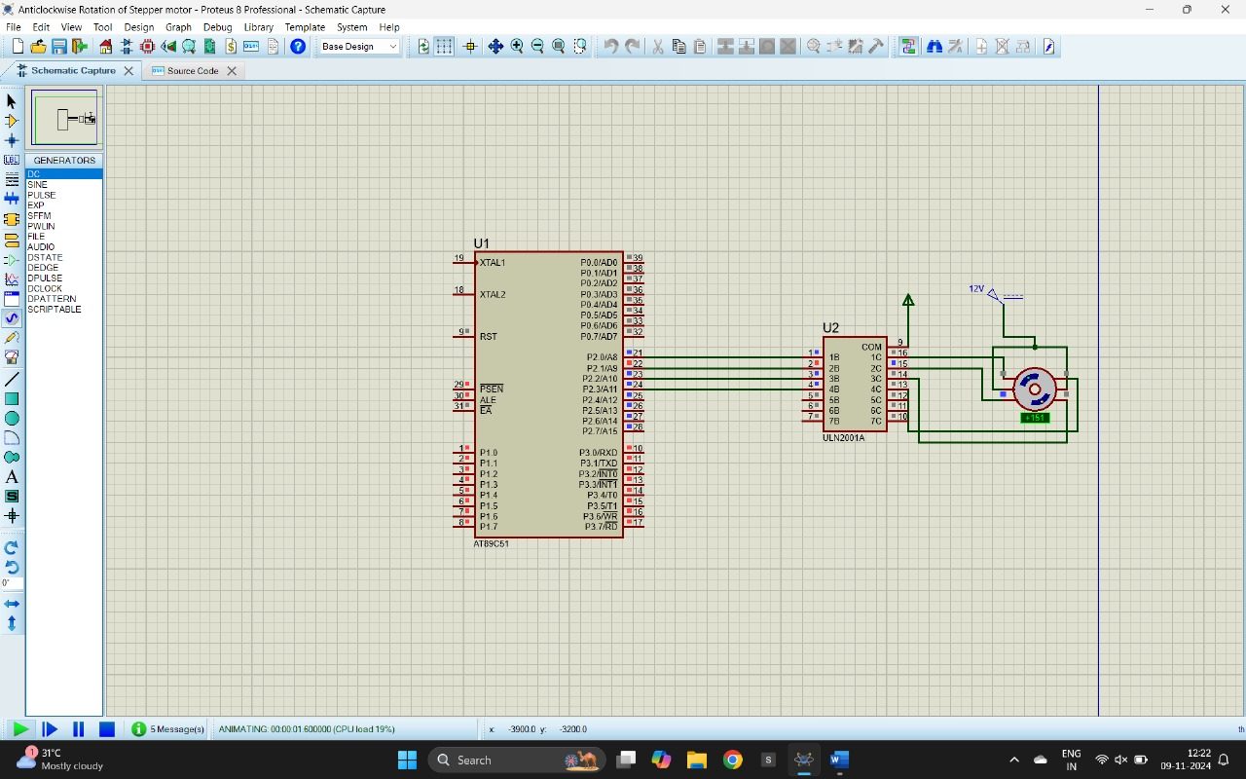

**OUTPUT:**

The stepper motor is rotating in clockwise direction in steps.

**RESULT:**

Thus, the program has been successfully verified and executed.